Mini Capstone #1

Title:

Collaborative Filtering based Recommender System using K Nearest Neighbor
Collaborative filtering is probably the most commonly used recommendation algorithm, there are two main types of methods:
- User-based collaborative filtering is based on the user similarity or neighborhood
- Item-based collaborative filtering is based on similarity among items
They both work similarly, let's briefly explain how user-based collaborative filtering works.
User-based collaborative filtering looks for users who are similar. This is very similar to the user clustering method done previously; where we employed explicit user profiles to calculate user similarity. However, the user profiles may not be available, so how can we determine if two users are similar?

Objectives
After completing this mini capstone you will be able to:
- Perform KNN-based collaborative filtering on the user-item interaction matrix

The dataset: "https://cf-courses-data.s3.us.cloud-object-storage.appdomain.cloud/IBM-ML321EN-SkillsNetwork/labs/datasets/ratings.csv"

User-item interaction matrix
For most collaborative filtering-based recommender systems, the main dataset format is a 2-D matrix called the user-item interaction matrix. In the matrix, its row is labeled as the user id/index and column labelled to be the item id/index, and the element (i, j) represents the rating of user i to item j.
Below is a simple example of a user-item interaction matrix:
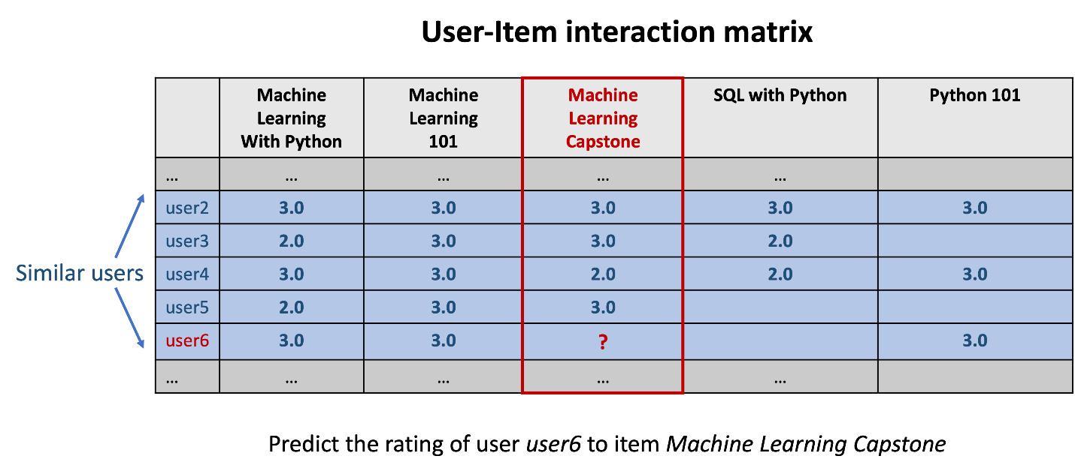

KNN-based collaborative filtering
As we can see from above, each row vector represents the rating history of a user and each column vector represents the users who rated the item. A user-item interaction matrix is usually very sparse as you can imagine one user very likely only interacts with a very small subset of items and one item is very likely to be interacted by a small subset of users.
Now to determine if two users are similar, we can simply calculate the similarities between their row vectors in the interaction matrix. Then based on the similarity measurements, we can find the k nearest neighbor as the similar users.
Item-based collaborative filtering works similarly, we just need to look at the user-item matrix vertically. Instead of finding similar users, we are trying to find similar items (courses). If two courses are enrolled by two groups of similar users, then we could consider the two items are similar and use the known ratings from the other users to predict the unknown ratings.
If we formulate the KNN based collaborative filtering, the predicted rating of user u to item i, ^r_ui is given by:
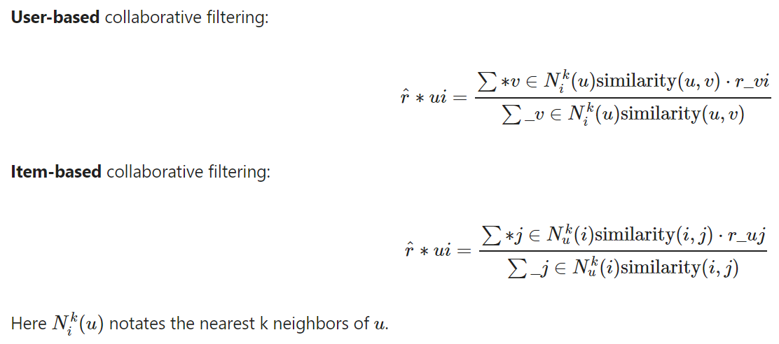

TASK: Perform KNN-based collaborative filtering on the user-item interaction matrix
TODO: Fit the KNN-based collaborative filtering model using the trainset and evaluate the results using the testset:

Appendix:

How to obtain the PDF template for writing Report
You can find similar structured reports, including code and visualizations, on platforms like Scribd (search for "Customer Segmentation Project Report") or ResearchGate (Choose a light-weight template).

